Question 2 Spring 2009

The probability that a component produced in a certain factory is defective is 0.01. A batch contains 200 components.

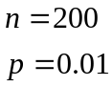

1) Calculate the probability that none of the components are faulty.
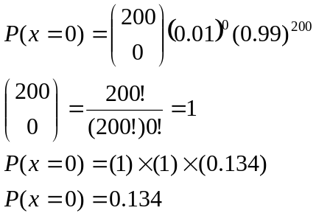

2) Calculate the probability that at least two of the components are faulty.

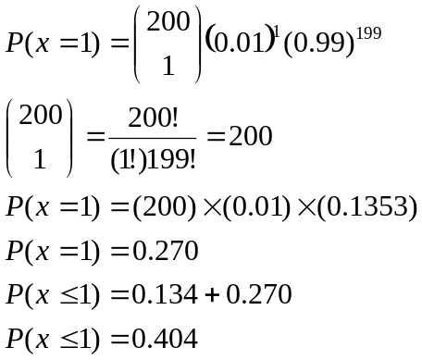

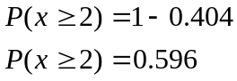

Binomial formula
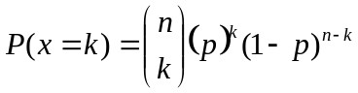

“From n choose k”
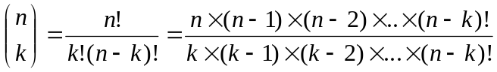

Example
